**Title:** Unveiling Attrition: A Power BI Exploration.

**Introduction:**

In this Power BI project, we're diving deep into employee attrition. By analyzing key data points, we aim to uncover insights that can help mitigate turnover and boost retention. Join us as we harness the power of analytics to drive actionable strategies and cultivate a resilient workforce.

Let's unlock the potential within your organization together.

Step 1 : Imported the data into power bi (power query)

Perform data labeling.

Data cleaning.

Data Encoding.

Step 2 : Power BI Dashboards :

1. 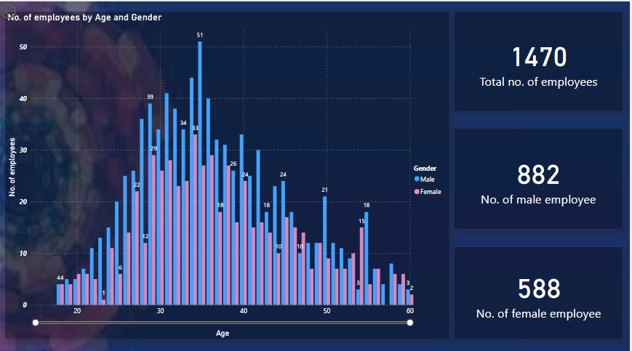

**Title : **Age and Gender Distribution Chart****

Step 1 : Used bin method to group the age

Stept 2 : ****Age and Gender Distribution Chart:****

* ****Visual Representation:**** Clustered column chart
* ****Description:**** This chart provides a clear illustration of the distribution of employees categorized by age groups and genders.
* ****X-axis:**** Age Groups
* ****Y-axis:**** Number of Employees
* ****Clusters:**** Male and Female
* ****Interpretation:**** Each cluster of columns represents a distinct gender category, with each column's height denoting the count of employees within specific age groups. This visualization enables easy comparison of age and gender distributions within the organization.

Step 3 : ****Employee Summary Cards:****

* ****Visual Representation:**** Cards
* ****Description:**** Three separate cards display key metrics:
  + Total Employees
  + Number of Male Employees
  + Number of Female Employees
* ****Interpretation:**** Each card presents a single numerical value, providing a snapshot of employee counts based on gender.

1. 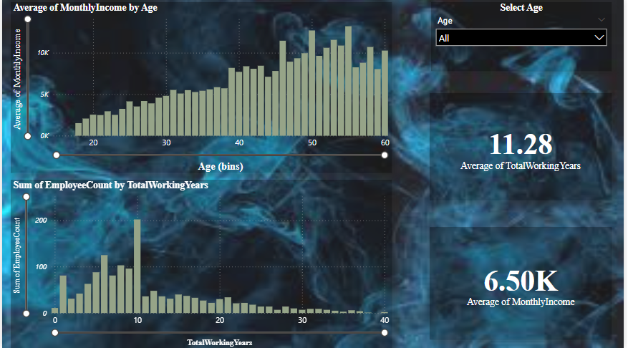

**Title: Average monthly income an employee count by working years.**

****Step 1 : Average Monthly Income by Age Chart:****

* ****Visual Representation:**** Clustered column chart
* ****Description:**** This chart illustrates the average monthly income for each age group.
* ****X-axis:**** Age Groups
* ****Y-axis:**** Average Monthly Income
* ****Clusters:**** Each cluster represents a different age group.
* ****Interpretation:**** The height of each column cluster indicates the average monthly income for the corresponding age group.

**Step 2 : **Employee Distribution by Total Working Years Chart:****

* ****Visual Representation:**** Clustered column chart
* ****Description:**** This chart illustrates the distribution of employees across different total working year ranges.
* ****X-axis:**** Total Working Years
* ****Y-axis:**** Number of Employees
* ****Clusters:**** Each cluster represents a different range of total working years.
* ****Interpretation:**** The height of each column cluster indicates the number of employees falling within the corresponding total working year range.

**Step 3 : **Age Slicer:****

* ****Functionality:**** Slicer
* ****Description:**** Allows stakeholders to dynamically select individual age ranges for analysis.
* ****Interpretation:**** Users can adjust the slicer to focus on specific age groups and observe how the distribution of total working years varies within those age ranges.

**Step 4 : **Average Working Years Card:****

****Visual Representation:**** Card

****Description:**** This card displays the average working years of employees within the organization.

****Interpretation:**** The numerical value on the card represents the average tenure of employees, indicating the typical length of service within the organization.

****Average Monthly Income Card:****

****Visual Representation:**** Card

****Description:**** This card displays the average monthly income of employees within the organization

****Interpretation:**** The numerical value on the card represents the average monthly income of employees, providing insight into the typical level of compensation.

1. 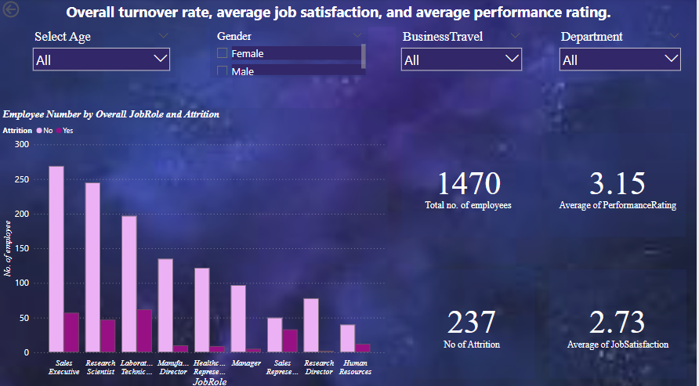

**Tittle : Overall turn over rate average, job satisfaction an average performance rating.**

**Step 1 : **Employee Distribution by Job Role and Attrition Chart:****

* ****Visual Representation:**** Clustered column chart
* ****Description:**** This chart illustrates the distribution of employees across different job roles, segmented by attrition status (e.g., attrited and retained).
* ****X-axis:**** Job Roles
* ****Y-axis:**** Number of Employees
* ****Clusters:**** Each cluster represents a different attrition status (e.g., attrited and retained).

****Interpretation:**** The height of each column cluster indicates the number of employees within specific job roles, segmented by attrition status.

**Step 2 : Age Slicer:**

Functionality: Slicer

Description: Allows users to dynamically filter employee data by age range.

**Gender Slicer:**

Functionality: Slicer

Description: Enables users to filter employee data by gender, facilitating gender-based analysis

**Department Slicer:**

Functionality: Slicer

Description: Enables users to filter employee data by department, facilitating department-specific analysis

**Travel Status Slicer:**

Functionality: Slicer

Description: Allows users to filter employee data by travel status, providing insights into travel-related employment characteristics.

**Step 3 :**

Total Employees Card:

Visual Representation: Card

Description: Displays the total number of employees within the organization.

Interpretation: Provides an overview of the workforce size.

Attrition Count Card:

Visual Representation: Card

Description: Displays the total number of employees who have left the organization (attrition).

Interpretation: Indicates the extent of attrition within the organization.

Average Job Satisfaction Card:

Visual Representation: Card

Description: Displays the average job satisfaction rating across all employees.

Interpretation: Provides insight into overall employee satisfaction levels.

Average Performance Rating Card:

Visual Representation: Card

Description: Displays the average performance rating across all employees.

Interpretation: Indicates the average performance level of the workforce.

1. 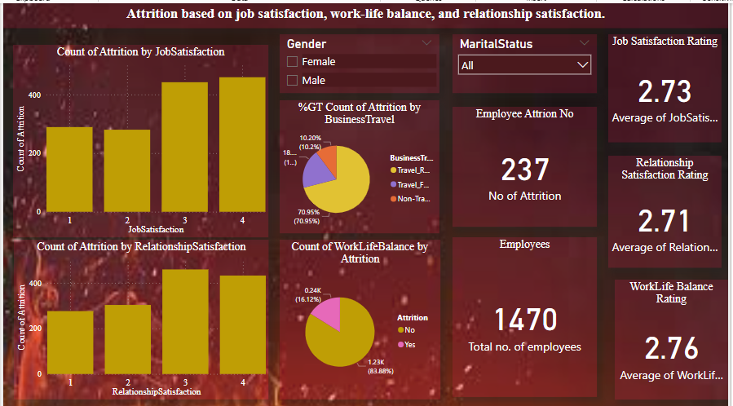 **Title : Predective Attrition based on Reasons**

**Step 1 :**Attrition Count by Job Satisfaction Stacked Column Chart:****

****Visual Representation:**** Stacked column chart

****Description:**** This chart illustrates the count of attrition cases stacked by different levels of job satisfaction.

****X-axis:**** Job Satisfaction Levels

****Y-axis:**** Count of Attrition

****Stacks:**** Each stack represents a different level of job satisfaction (e.g., Low, Medium, High).

****Interpretation:**** Provides insights into how attrition cases are distributed across different levels of job satisfaction.

**Step 2 :**Attrition Count by Relationship Status Stacked Column Chart:****

* ****Visual Representation:**** Stacked column chart
* ****Description:**** This chart illustrates the count of attrition cases stacked by different relationship statuses.
* ****X-axis:**** Relationship Status
* ****Y-axis:**** Count of Attrition Cases
* ****Stacks:**** Each stack represents a different relationship status (e.g., Single, Married, Divorced).
* ****Interpretation:**** Provides insights into how attrition cases are distributed across different relationship statuses.

**Step 3 :**

**Gender Slicer:**

Functionality: Slicer

Description: Allows users to dynamically filter attrition data by gender.

**Marital Status Slicer:**

Functionality: Slicer

Description: Enables users to filter attrition data by marital status, facilitating analysis based on relationship status.

**Step 4 :Total Employees Card:**

Visual Representation: Card

Description: Displays the total number of employees within the organization.

Interpretation: Provides an overview of the workforce size

**Attrition Count Card:**

Visual Representation: Card

Description: Displays the total number of employees who have left the organization (attrition).

Interpretation: Indicates the extent of attrition within the organization.

**Average Job Satisfaction Card:**

Visual Representation: Card

Description: Displays the average job satisfaction rating across all employees.

Interpretation: Provides insight into overall employee job satisfaction levels.

**Average Work-Life Balance Card**:

Visual Representation: Card

Description: Displays the average work-life balance rating across all employees.

Interpretation: Indicates the average level of work-life balance perceived by employees.

**Average Relationship Satisfaction Card:**

Visual Representation: Card

Description: Displays the average relationship satisfaction rating across all employees.

Interpretation: Provides insight into the average level of relationship satisfaction among employees.

**Step 5 : **Attrition Distribution by Business Travel Pie Chart:****

* ****Visual Representation:**** Pie chart
* ****Description:**** This chart illustrates the distribution of attrition cases based on business travel
* ****Slices:**** Each slice represents a different business travel category (e.g., Travel Frequently, Travel Rarely, No Travel).
* ****Interpretation:**** Provides insights into the proportion of attrition cases within each business travel category

**Step 6 : **Work-Life Balance Distribution by Attrition Pie Chart:****

* ****Visual Representation:**** Pie chart
* ****Description:**** This chart illustrates the distribution of work-life balance ratings among employees who have left the organization (attrition).
* ****Slices:**** Each slice represents a different work-life balance rating category.
* ****Interpretation:**** Provides insights into the proportion of attrition cases within each work-life balance rating category.

**Made By**

**Saurabh S Singh**